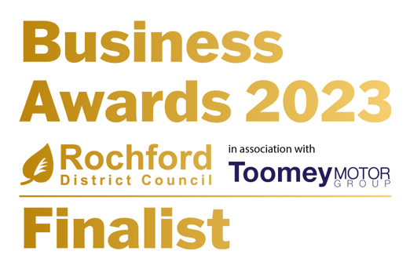

FOR IMMEDIATE RELEASE

I am Emily Design & Marketing Shines as Finalist for Micro Business of the Year 2023 at Rochford District Business Awards

I am Emily Design & Marketing, a renowned graphic design agency, proudly stood as a finalist for the Micro Business of the Year 2023 category at the local Rochford District Business Awards.

Emily Hewett, the visionary director and founder of I am Emily Design & Marketing, was in attendance at the celebratory event on January 26th, 2023, held at Apton Hall, Essex. The evening served as a platform to honour and applaud the exceptional achievements of local businesses.

The Rochford District Council, organisers of the awards, highlighted the significance of these accolades in recognising and celebrating the remarkable accomplishments within the vibrant business community.

Expressing her pride and excitement, Emily Hewett shared, "Being named a finalist in the Rochford District Business Awards is a tremendous honour. This recognition on a local level reinforces the dedication, hard work, and remarkable talent that our team consistently brings to our clients. It further ignites our passion to deliver the finest service."

At the helm of I am Emily Design & Marketing, Emily's leadership is anchored in a profound passion for crafting captivating design solutions. With an extensive industry background, Emily excels in elevating brand identity, fostering engagement, and driving business success through meticulously tailored strategies. Her unwavering commitment to clients' achievements is palpable through hands-on, results-oriented approaches, forging impactful and enduring partnerships.

For more information about I am Emily Design & Marketing and their exceptional services, please visit www.iamemily.co.uk.

For media enquiries and further details, please contact:
Emily Hewett
emily@iamemily.co.uk
07760 806 686
Photos can be provided on request.

