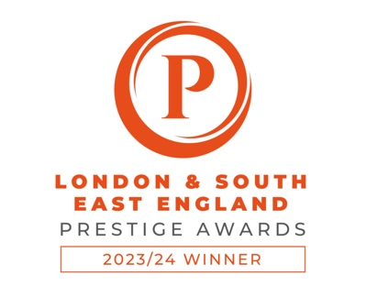

I am Emily Design & Marketing named 2023 Graphic Design Agency of the Year

I am Emily Design & Marketing is thrilled to announce its recent achievement of being awarded the prestigious title of Graphic Design Agency of the Year, Essex by the renowned Prestige Awards. The esteemed recognition comes as a testament to the agency's unwavering dedication to delivering exceptional design solutions and services.

The Prestige Awards, initiated by Corporate LiveWire, was established with the mission of acknowledging and celebrating the outstanding contributions of small and independent businesses that consistently provide exceptional products and services to local communities and beyond. The awards focus on recognising excellence within specific regions and cities with vibrant SME communities.

Osmaan Mahmood, Founder & CEO of Prestige Awards, highlighted the unique strengths of small businesses, stating, "While small businesses may lack the scale of multinational corporations, they often excel in delivering personalized, service-driven experiences that larger organizations may lack."

I am Emily Design & Marketing stood out to the judging panel for their exceptional commitment to their clients, evident through their personal approach, community engagement, and deep passion for their craft. Emily Hewett, Director, and Founder of I am Emily Design & Marketing, expressed her pride in the recognition, stating, "Winning the Graphic Design Agency of the Year award is a true honour. It reflects the hard work, dedication, and talent that our team brings to our clients. This achievement further fuels our determination to continue delivering the highest level of service."

The judging process for the Prestige Awards entails a thorough evaluation of various criteria, including service excellence, product/service quality, innovation, value, ethical and sustainable practices, and consistent performance. I am Emily Design & Marketing's ability to demonstrate strengths in these key areas played a pivotal role in securing this prestigious accolade.

The agency's commitment to enhancing brand identity, engagement, and business success through tailored design and marketing strategies has cemented its position as a leader in the industry. With a team dedicated to crafting captivating solutions, I am Emily Design & Marketing continues to uphold its mission of delivering top-notch service and empowering clients to achieve their goals.

For more information about I am Emily Design & Marketing and their award-winning services, please visit www.iamemily.co.uk

For media enquiries and further details, please contact:
Emily Hewett
emily@iamemily.co.uk
07760 806 686
Photos can be provided on request.

